EXP.NO.2

WRITE A JAVASCRIPT PROGRAM TO VALIDATE THE
FOLLOWING FIELDS OF THE HTML REGISTRATION PAGE

AIM:

To write JavaScript code to validate user input in a registration form. The validation will
ensure that the data entered by the user meets specific criteria for each field. This will help in
maintaining data integrity and prevent invalid submissions.

ALGORITHM:
A) Input:
- The user fills in the following fields: First Name, Password, E-mail, Mobile Number, Last Name, and Address.

B) Validation Steps:
1. Validate First Name:
- Check if the first name contains only alphabets.
- Ensure the length of the First Name is at least 6 characters.
- If any of these conditions fail, display an error message indicating the required input.
2. Validate Password:
- Check if the password is at least 6 characters long.
- If it is less than 6 characters, display an error message.
3. Validate E-mail:
Use a regular expression to check if the email follows the standard pattern:
- name@domain.com.
- Ensure that the email contains no invalid characters and matches the required
- pattern.
- If it doesn’t match, display an error message indicating an invalid email
- format.
4. Validate Mobile Number:
- Check if the mobile number contains exactly 10 digits.
- Ensure there are no alphabets or special characters.
- If the number is invalid, display an error message indicating the correct format.
5. Validate Last Name:
- Ensure the Last Name field is not empty.
- If it is empty, display an error message.

6. Validate Address:
- Ensure the Address field is not empty.
- If it is empty, display an error message.

CODE:
<!DOCTYPE html>
<html lang="en">
<head>
<meta charset="UTF-8">
<meta name="viewport" content="width=device-width, initial-scale=1.0">
<title>Registration Form Validation</title>

<style>

body{
font-family: Arial;
background-color: #f2f2f2;
}

.container{
width: 400px;
margin: auto;
background: white;
padding: 20px;
margin-top: 50px;
border-radius: 10px;
box-shadow: 0px 0px 10px gray;
}

h2{
text-align: center;
color: darkblue;
}

input, textarea{
width: 100%;
padding: 10px;
margin-top: 10px;
}

button{
width: 100%;
padding: 10px;
background-color: green;
color: white;
border: none;
margin-top: 15px;
font-size: 16px;
cursor: pointer;
}

button:hover{
background-color: darkgreen;
}

</style>
</head>

<body>

<div class="container">

<h2>Registration Form</h2>

<form onsubmit="return validateForm()">

<input type="text" id="fname" placeholder="First Name">

<input type="text" id="lname" placeholder="Last Name">

<input type="password" id="password" placeholder="Password">

<input type="text" id="email" placeholder="E-mail ID">

<input type="text" id="mobile" placeholder="Mobile Number">

<textarea id="address" placeholder="Address"></textarea>

<button type="submit">Register</button>

</form>

</div>

<script>

function validateForm(){

// Get values
let fname = document.getElementById("fname").value.trim();
let lname = document.getElementById("lname").value.trim();
let password = document.getElementById("password").value.trim();
let email = document.getElementById("email").value.trim();
let mobile = document.getElementById("mobile").value.trim();
let address = document.getElementById("address").value.trim();

// First Name Validation
let namePattern = /^[A-Za-z]+$/;

if(fname.length < 6 || !namePattern.test(fname)){
alert("First Name must contain only alphabets and minimum 6 characters");
return false;
}

// Last Name Validation
if(lname == ""){
alert("Last Name should not be empty");
return false;
}

// Password Validation
if(password.length < 6){
alert("Password should contain minimum 6 characters");
return false;
}

// Email Validation
let emailPattern = /^[^ ]+@[^ ]+\.[a-z]{2,3}$/;

if(!email.match(emailPattern)){
alert("Enter valid E-mail ID");
return false;
}

// Mobile Number Validation
let mobilePattern = /^[0-9]{10}$/;

if(!mobile.match(mobilePattern)){
alert("Mobile Number should contain exactly 10 digits");
return false;
}

// Address Validation
if(address == ""){
alert("Address should not be empty");
return false;
}

alert("Registration Successful");

return true;
}

</script>

</body>
</html>

OUTPUT:
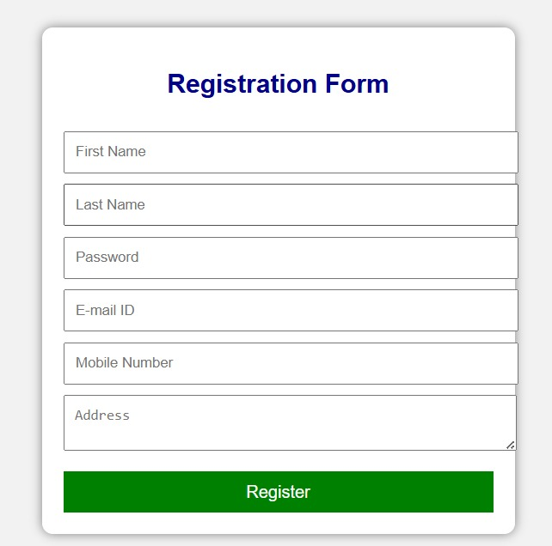
RESULT:
HTML page with Form is created and is validated using Javascript

